Ali Albayrak – P304320

Assessment 1.1

Test Table

|  |  |  |  |
| --- | --- | --- | --- |
| Test Area | Car Name | Node Position | Output |
| Add First | Honda | - | Honda |
| Add Last | Hyundai | - | Honda,Hyundai |
| Add First | Toyota | - | Toyota,Honda,Hyundai |
| Add Before | Mazda | 2 | Toyota,Honda,Mazda,Hyundai |
| Add After | Mercedes | 0 | Toyota,Mercedes,Honda,Mazda,Hyundai |
| Remove | Mazda | - | Toyota,Mercedes,Honda,Hyundai |
| Search | Honda | - | Honda will selected on listbox. |
| Clear | - | - | Clears everything |

Add First:

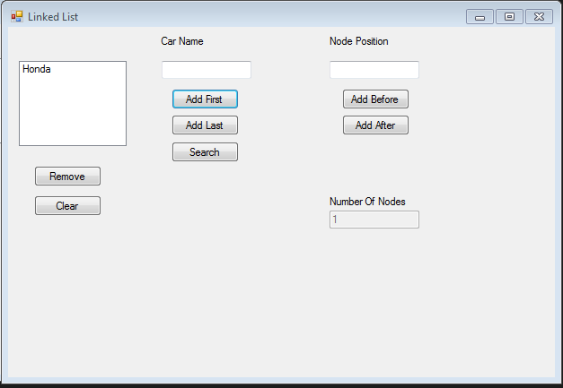

Add Last:

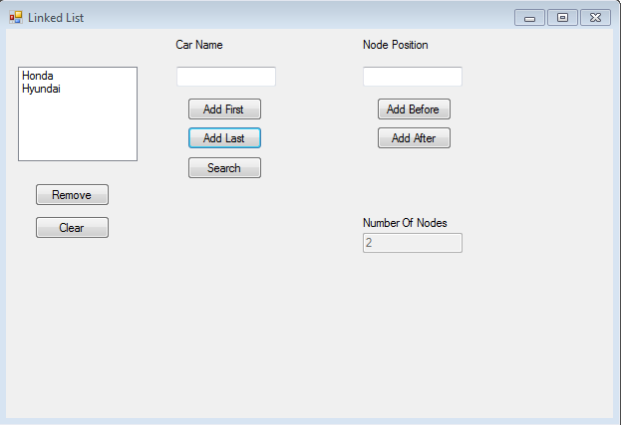

Add First:

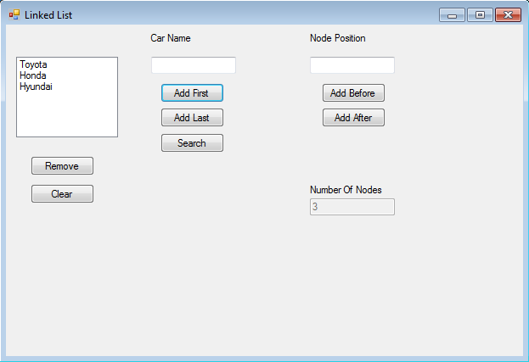

Add Before:

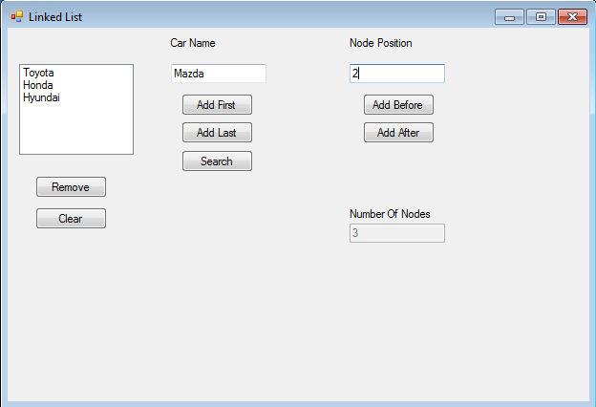

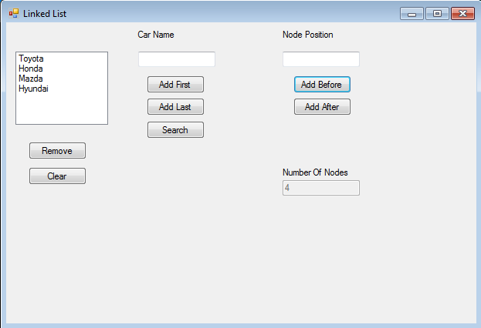

Add After:

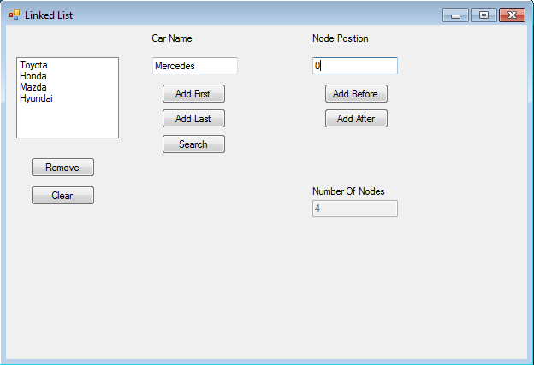

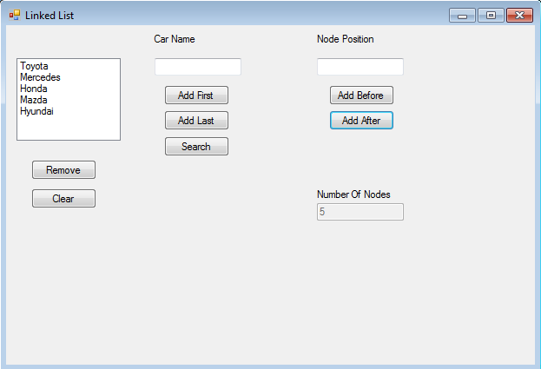

Remove:

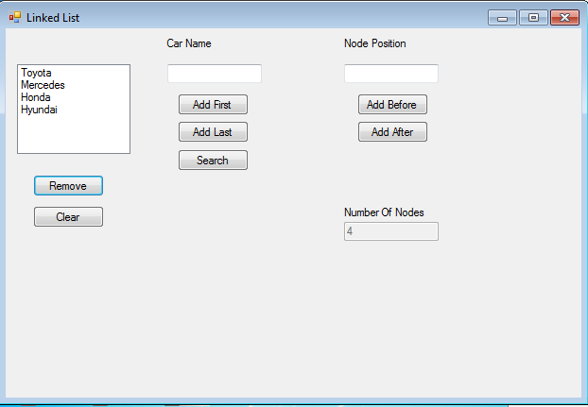

Search:

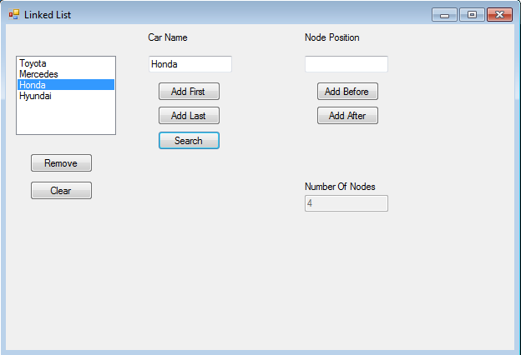

Clear:

